Obesity: Not an Issue Anymore!

Over the past decade, the obesity rates amongst children in Canada have shot up at an alarming rate. In fact, in 2007 the average weight of a 4th grade student was 95 pounds whereas now, that number is 174! Many top-tier statisticians have followed this trend and attributed this to a lack of walking. In fact, Dr. Alternative (a top researcher at Stanford) has said that his hypothesis tests have proven, without a doubt, that the entirety of this epidemic is a result of parents sending their children to school by busses.

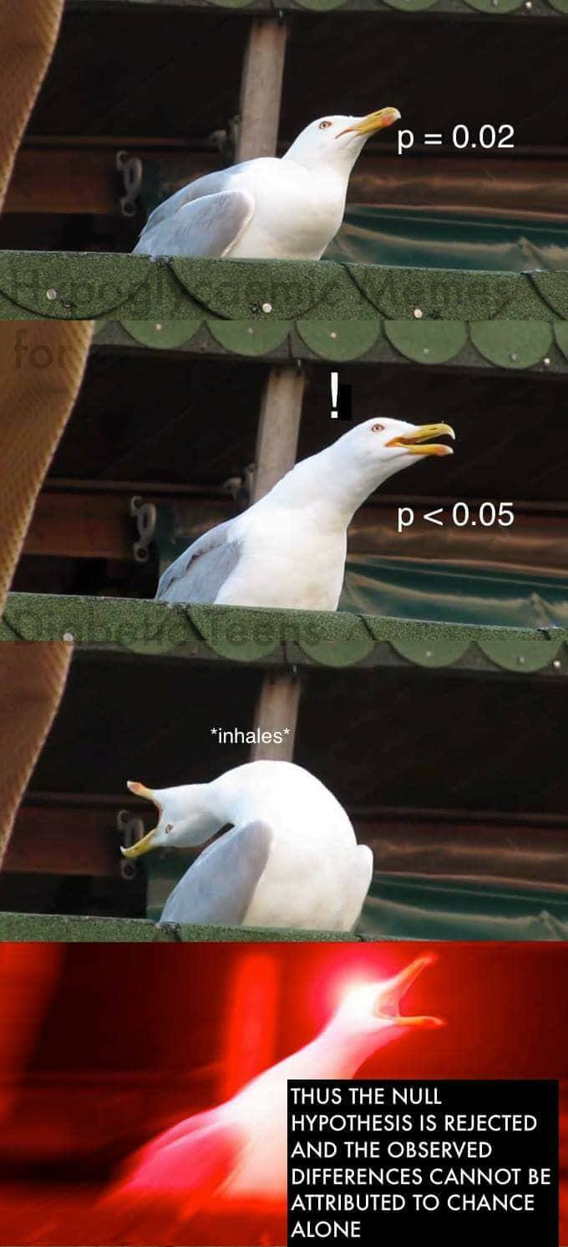

Now, you might ask:

“But, there were busses in 2007 as well, what’s different now?”

A completely valid question for which there is a very logical answer. The famous economist, Milton Freidman has shown that this is due to the terrible economy. He states “Due to the economic downtown over the past decade, families have had to resort to using McDonalds as a primary source of nutrition due to their low, low prices. This has caused an exponential increase in weight amongst children. Now, obviously you cannot expect families to stop feeding their children and, because all they can afford is McDonalds, they must make some other compromises to stay in shape. We all know that skipping the morning walk means missing out on 1500 burned calories therefore, if kids started walking to school more, they can offset the surplus of calories from switching to a McDonalds-only diet”. Since Friedman is an economist, he obviously isn’t wrong.

Luckily, a group of astute students from Simon Fraser University have thought of a brilliant way to remedy this issue and save our futures. They have developed a “human bus” that clusters students living together in groups and then creates optimized walking routes for them. Since the initial release of this platform, there has been a 10000% decrease in obesity! It is a very complicated system and what I have said here does not do it justice.

In the age of impending doom for our species, we can rest easy knowing that one of the major threats to our children has been contained thanks to a group of great students. I had the privilege of speaking to Brad (one of these students) who says that him and his team are now going to focus on A.I: “We will create a great A.I – the best A.I the likes of which the world has never seen – one that won’t kill us, too” he says. And let’s hope that they deliver – it might be the only shot we got!